**Format for uploading details in Github and Slack in word file format**

**(Fill this format(docx) daily and upload it in both Github and Slack)**

**Student Name : SURYA PRAKASH S**

**Class and Sec : VI B**

**USN : 4AL17CS101**

|  |  |  |  |  |
| --- | --- | --- | --- | --- |
| **Online Test Details** | | | | |
| **Subject** | **CGV**  **CNSC** | | | |
| **Semester** | **VI -B** | | **Duration** | **30 Minutes**  **40 Minutes** |
| **% of marks** | | **77**  **52** | | |

**Encl : snapshot of the test result**

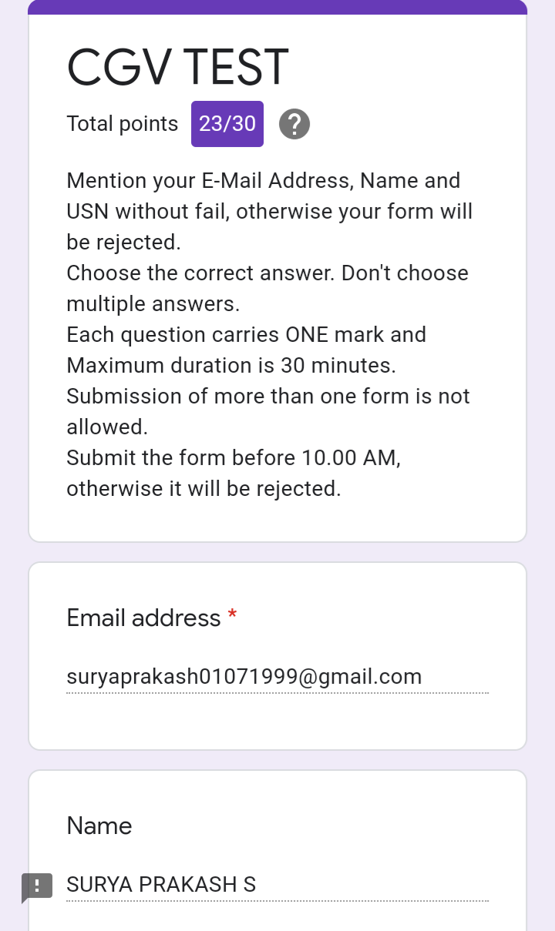

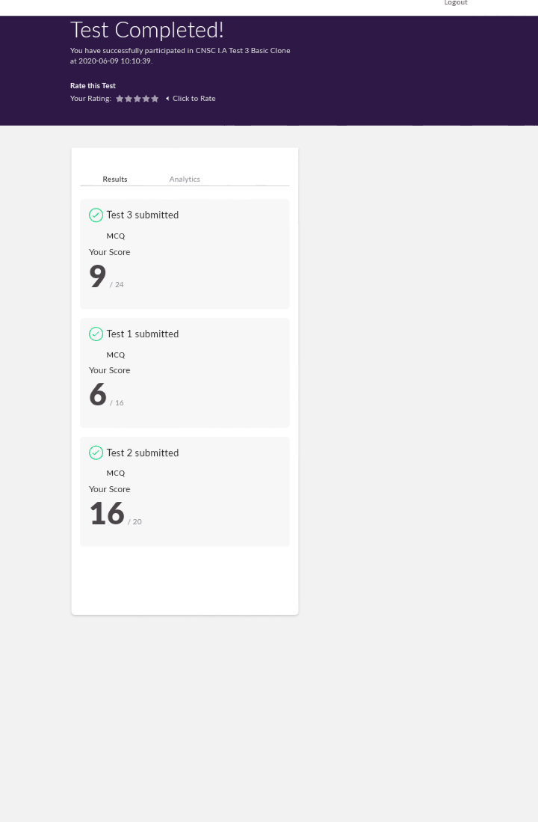

|  |  |  |  |
| --- | --- | --- | --- |
| **Certification Course Details** | | | |
| **Course** | **Dara Visualization using Python** | | |
| **Certificate Provider** | **Cognitiveclass.ai** | **Duration** | **10 hours** |

**Encl : snapshots of the daily class acitivities (atleast two snap shots)**

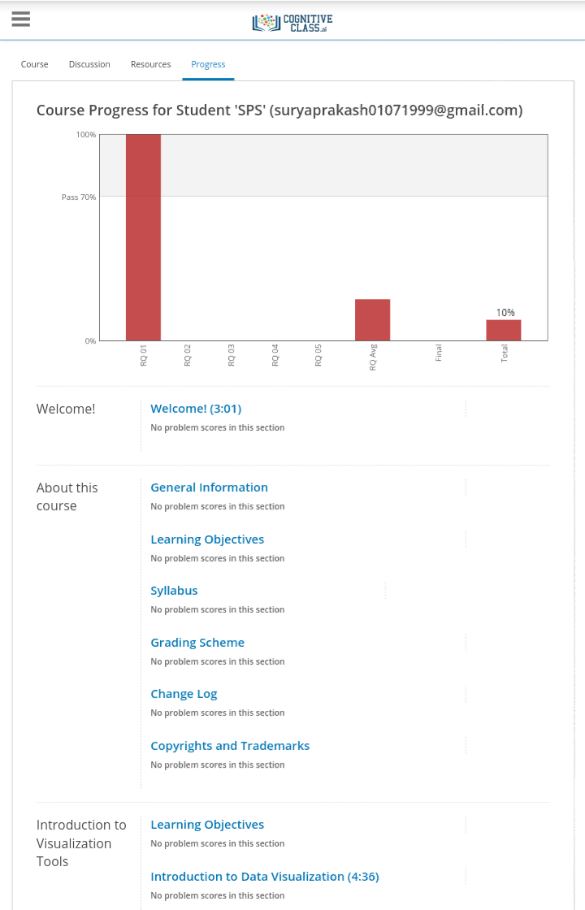

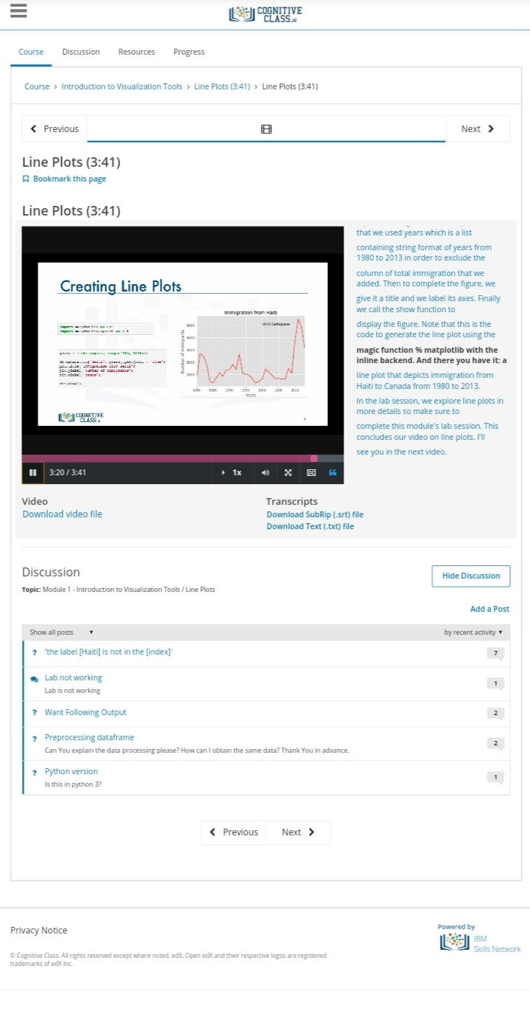

|  |  |
| --- | --- |
| **Coding Challenges** | |
| **Problem Statement: 1. Python Program to Check Whether a String is a Palindrome or not Using Recursion 2. Python Program to count even and odd numbers 3. Python Program to Check Whether a String is a Palindrome or not Using Recursion**  **4. Write a Java Program to remove all white spaces from a string without using replace() 5. Python program to implement perfect sum problem 6. C program to rotate the matrix by k times** | |
| **Status: Completed** | |
| **Uploaded the report both in Github & Slack** | **Yes** |

**Encl : snapshots of your response to challenge.**

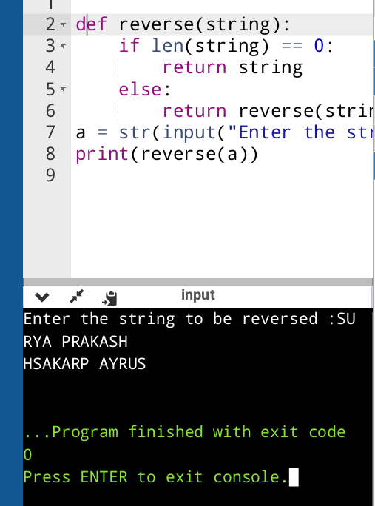

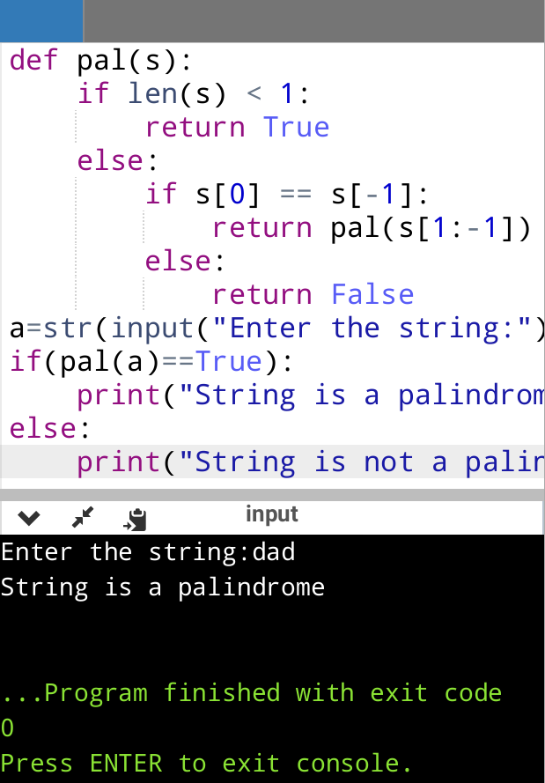

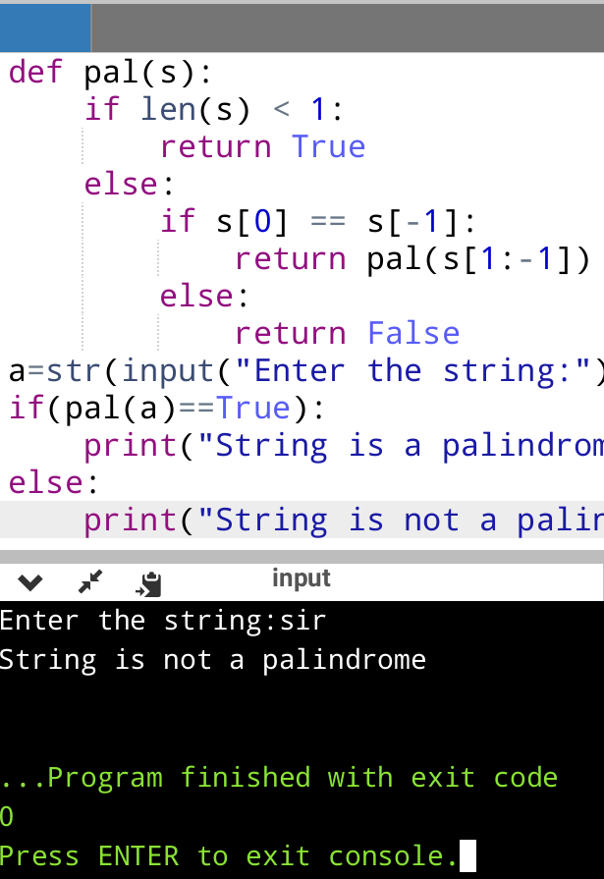

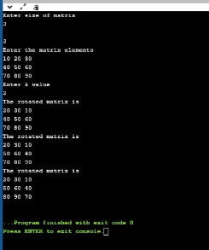

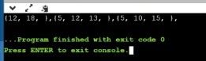

https://github.com/SPSSURYA/Online-Coding-And-Certification-Course